Week 8 practical

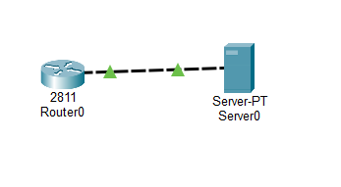
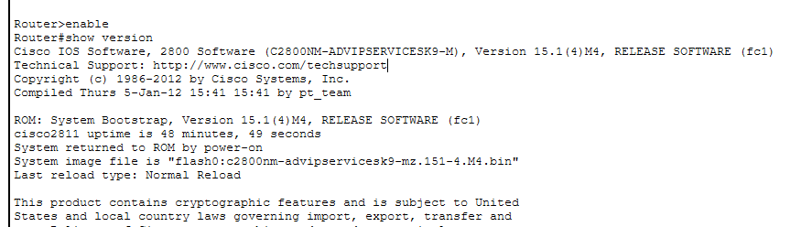

- Password recovery: A process to regain access to your account or device without losing your data. It usually involves resetting your password through security questions, email verification, SMS codes, or recovery keys. It is usually used when you forgot your password but still want to keep your files, apps, and settings.
*Factory reset: A process that erases all data, apps, and settings on a device, returning it to its original state as if it were brand new. We usually use it when you’re selling, donating, or giving away the device and want to remove personal data.

Normally choose password recovery as the first choice if your only problem is forgotten credentials. It’s less disruptive and preserves your data. and factory reset is the fallback when recovery isn’t possible or when you deliberately want to erase everything for security or performance reasons.

- On a Cisco 2800 series router, you interrupt the boot sequence by sending a Break signal (often Ctrl+Break or Ctrl+Shift+6 depending on terminal software). Yes, this can differ slightly by platform and terminal emulator, but the principle is the same: you must send a break during the first 60 seconds of boot to drop into ROMMON mode. (Computer Networkings Notes, 2026)

- The configuration register value 0x2142 tells a Cisco router to ignore the startup configuration file (NVRAM) during boot. By setting the register to 0x2142 and rebooting, the router ignores the saved configuration (where the password is stored).

- Router will reload with old password, and you’ll be locked out again

Task 2
- Running-Config is temporary it exists only while the router is powered on. If the router reloads or loses power, unsaved changes in running-config are lost.

*Startup-Config is permanent it survives reloads and power cycles until you overwrite it.

- Copy to Local Storage (Flash or USB). Many Cisco routers and switches support saving the configuration file directly to onboard flash memory or an attached USB drive.

- Step 1: Centralize Backups on a Server

Step 2: Use Scheduled Scripts
Step 3: Leverage Network Management Systems (NMS)
Step 4: Enable Syslog or SNMP Triggers
Step 5: Version Control Integration
Step 6: Test and Validate

Task 3

- Show flash
- The boot system command in Cisco IOS is used to tell the router which IOS image to load during startup. Its saved as part of the startup configuration (NVRAM).

- Verifying an MD5 checksum after copying an IOS image is crucial for ensuring the integrity and reliability of the software you’re about to run on your router or switch.

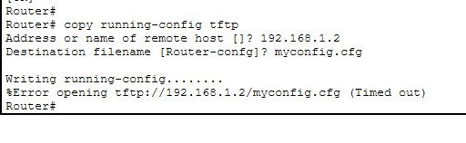

Step 3 — Make a deliberate visible change

